Solution Architecture
Maitribodh Access Management System (MAMS): technology stack, application design and infrastructure
Item | Value
Document | Solution Architecture, Technology Stack and Infrastructure Requirements
Version | 2.2 (build and packaging details added; based on BRD v1.2, FRD v1.2, Database Design v2.0)
Date | 8 October 2026
Status | Draft for review
Project | Maitribudh-AMS containing Maitribudh-API and Maitribudh-UI
Stack | React (PWA), Node.js with Express, Amazon RDS for PostgreSQL, AWS
Ports | UI on 3000, API on 6200

Changes in versions 2.0 to 2.2
Area | Change
External services | Email, SMS, WhatsApp and OTP removed from Phase 1 (recurring cost). No SMTP or SMS keys in Secrets Manager
QR | QR codes are generated by the API on request and signed; no QR images stored in S3
New functions | Bulk upload, location access (open / restricted areas), multiple gates, Resident Status, accompanying members, expanded audit
Database | Aligned with the simplified 12-table design (Database Design v2.0); no database jobs, views or functions
Project structure | One project Maitribudh-AMS with Maitribudh-API and Maitribudh-UI; full folder structure defined
Coding standards | ES6+ modules, higher-order components, small components, utils, constants files, ESLint, Prettier, JSDoc
Configuration | Separate configuration per environment (local, dev, UAT, production); UI port 3000, API port 6200
Background jobs | Overstay alerts and clean-up run in the API with node-cron instead of the database
Diagrams | New solution architecture, application layer and CI/CD diagrams
Version 2.1 | Full file-level structure for Maitribudh-UI (pages, components, Redux actions, reducers, selectors, services) and Maitribudh-API; Redux data flow diagram and worked example
Version 2.2 | New section 8: UI build with Vite, API build and Docker image, file upload with Multer, Material UI setup, loaders; Appendix A: webpack alternative

Contents
1. Purpose and Scope
2. Architecture Overview
3. Technology Stack
4. Project Structure
5. Application Design
6. Coding Standards
7. Environment Configuration
8. Build, Packaging and Key Libraries
9. Security Architecture
10. Data Architecture
11. External Integrations
12. Background Jobs
13. AWS Infrastructure
14. CI/CD and Environments
15. Non-Functional Requirements
16. AWS Services Required
17. Client Inputs and Infrastructure Checklist
Appendix A. webpack Alternative for Maitribudh-UI

1. Purpose and Scope
This document defines how MAMS is built and hosted: the technology stack, the structure of the two applications, the coding standards the team follows, environment configuration, security, AWS infrastructure and the delivery pipeline. It follows the requirements in BRD v1.2 and FRD v1.2 and the database in Database Design v2.0.
In scope (Phase 1) | Not in Phase 1
Registration (manual, walk-in, bulk upload) with photo and Resident Status | Email, SMS and WhatsApp notifications
Approval workflow for Staff and Parivar Member | OTP of any kind
QR generation, public QR lookup, front-desk print | Access-control hardware (turnstiles, card readers)
Gate verification, check-in and check-out across gates and locations | SSO, MFA, Google / Microsoft login
Location assignment and restricted-area warning | Native mobile app (PWA is used)
Dashboard, inside list, overstay alerts, blacklist | Multiple Ashrams, languages other than English
Six reports, Visit History export, in-app notifications, audit log | Redis cache (only if load requires it)

2. Architecture Overview
MAMS is a three-tier web application. The React PWA is served from Amazon S3 through CloudFront. Calls to /api/* go through CloudFront to an Application Load Balancer and the Express API on ECS Fargate. The API is the only component that talks to the database (RDS PostgreSQL) and to the file bucket (S3). Secrets come from AWS Secrets Manager.
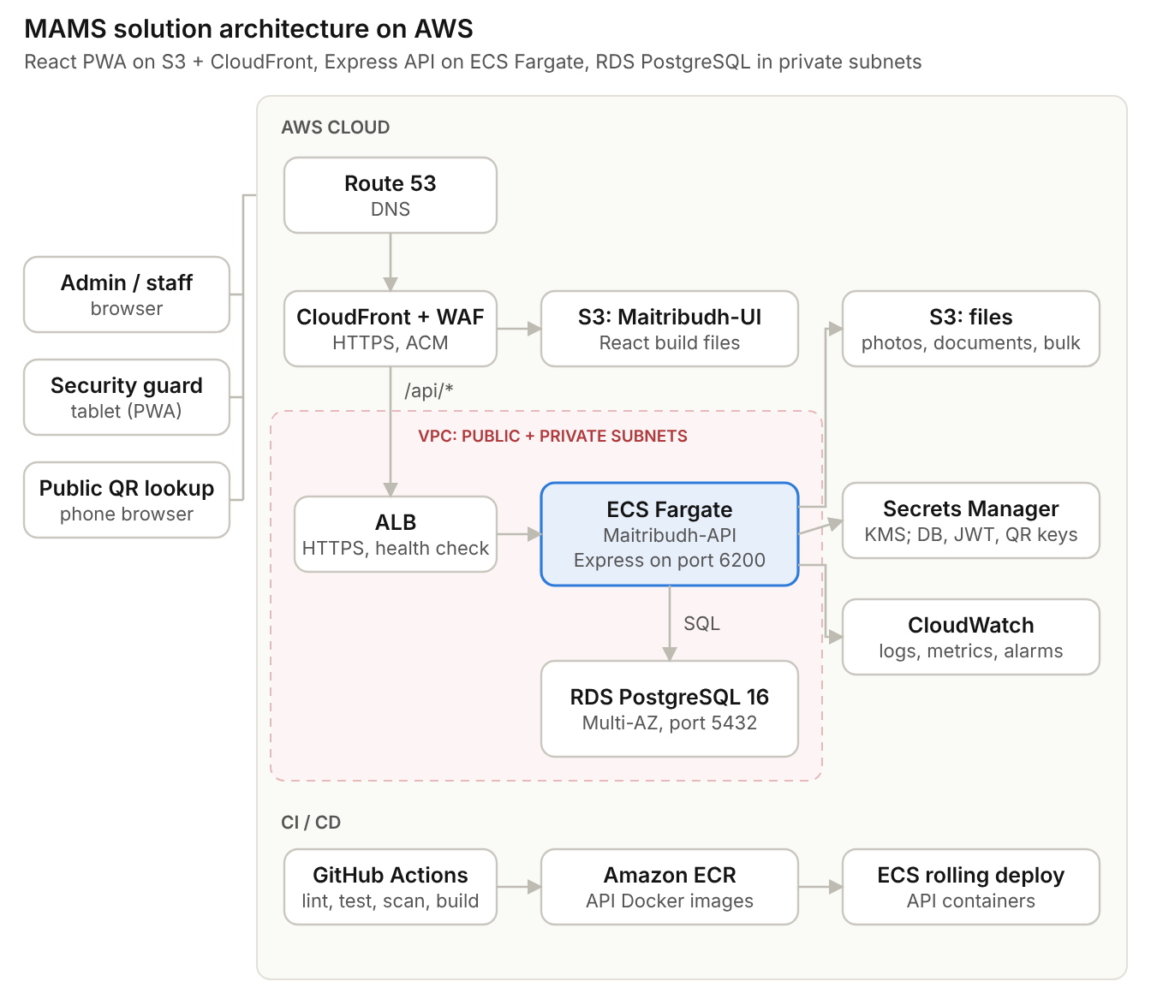
Figure 1. Solution architecture on AWS

2.1 Architecture principles
Principle | How it is applied
Thin database, logic in the API | The database holds 12 tables with keys and a few integrity rules. Approval, gate checks, QR, lockout and audit are coded and tested in the API
Stateless API | JWT authentication; no server sessions, so ECS tasks can scale out and be replaced at any time
Private by default | API and database run in private subnets; S3 buckets are private and files are served through short-lived pre-signed URLs
One responsibility per layer | Routes, middlewares, controllers, services and repositories in the API; pages, small components, HOCs, store and API services in the UI
Configuration outside code | All environment values come from environment files locally and from ECS task configuration / Secrets Manager in AWS; constants live in constants files
Automated quality gates | ESLint, Prettier, unit tests and dependency scans run on every pull request; nothing merges with lint errors

3. Technology Stack
Versions are the current stable releases at project start; the indicative versions below were current when this document was written.

3.1 Frontend: Maitribudh-UI
Technology | Purpose | Notes
React (19) with Vite | All screens: registration, approval, gate, dashboard, reports, masters, users | Vite replaces Create React App (no longer maintained); dev server on port 3000
Redux Toolkit | Application state: session, master data, screen data, request status | Async actions with createAsyncThunk, reducers with createSlice, selectors per module
React Router (v7) | Role-based navigation and route guards | Guards built as HOCs (withAuth, withRole)
Material UI (MUI) | Forms, tables, dialogs, cards, dashboard widgets | One theme file; no inline colours
React Hook Form + Zod | Form state and validation | Validation rules from the FRD kept in schema files
Axios | HTTP client used only by services/ | One httpClient instance with interceptors for token, errors and correlation id
html5-qrcode | QR scanning with the device camera at the gate | Rear camera, continuous scan, beep / vibrate
vite-plugin-pwa | Installable PWA for gate tablets | Offline mode is not required in Phase 1
Vitest + React Testing Library | Unit and component tests

3.2 Backend: Maitribudh-API
Technology | Purpose | Notes
Node.js (22 LTS or newer LTS) | Runtime | ES modules ("type": "module")
Express (5) | REST API under /api/v1 | Runs on port 6200
pg (node-postgres) | PostgreSQL access with a connection pool | Parameterised queries only; no string-built SQL
jsonwebtoken | JWT access tokens | Guard tokens 12 hours; other roles 30-minute idle timeout
bcrypt | Password hashing | Cost factor 12
zod | Request validation | One schema per endpoint
multer + AWS SDK v3 (S3) | Photo, document and bulk file upload | Max 5 MB; JPG, PNG, PDF; bulk: XLSX / CSV
qrcode | QR image generation (PNG) on request | Token AMS1.<Person ID>.<version>.<HMAC>
exceljs | Bulk upload parsing and Visit History export | Excel and CSV
helmet, cors, express-rate-limit | HTTP security headers, allowed origins, login rate limit
pino | Structured JSON logging to CloudWatch | No console.log in code
node-cron | Overstay alerts (5 min) and daily clean-up | Runs on one task only (section 12)
swagger-ui-express | API documentation (OpenAPI) at /api-docs | Disabled in production
Jest + Supertest | Unit and API tests

3.3 Data, storage and platform
Component | Choice | Purpose
Database | Amazon RDS for PostgreSQL 16, Multi-AZ | 12 tables (Database Design v2.0): users, categories, locations, lookups, persons, assignments, approvals, blacklist, visits, bulk uploads, notifications, audit log
File storage | Amazon S3 (private) | Photos, documents, bulk upload files, report exports
Cache | Not in Phase 1 | Amazon ElastiCache (Redis) only if dashboard load requires it
Containers | Docker, Amazon ECR, ECS Fargate | API hosting with rolling deployments
Infrastructure as code | Terraform | Same definitions for Dev, UAT and Production
Source control and CI/CD | GitHub and GitHub Actions | Lint, test, scan, build and deploy

4. Project Structure
The project Maitribudh-AMS is one repository with two applications. Each application has its own dependencies, configuration, tests and pipeline.
Maitribudh-AMS/
├── Maitribudh-API/ Node.js + Express REST API (port 6200)
├── Maitribudh-UI/ React PWA (port 3000)
├── .github/workflows/ api-ci.yml, ui-ci.yml
├── docs/ BRD, FRD, Database Design, Solution Architecture
├── .editorconfig shared editor settings
└── README.md how to run both applications

4.1 Maitribudh-API
Maitribudh-API/
├── src/
│ ├── server.js starts the HTTP server on config.port (6200)
│ ├── app.js Express app: security middlewares, routes, error handler
│ ├── config/
│ │ ├── index.js reads environment variables once
│ │ ├── db.js pg Pool (TLS) and transaction helper
│ │ ├── s3.js S3 client
│ │ └── logger.js pino logger
│ ├── constants/
│ │ ├── roles.js ROLES
│ │ ├── status.js PERSON_STATUS, VISIT_STATUS, LOCATION_TYPE ...
│ │ ├── messages.js FRD message codes and texts (MSG-GATE-03 ...)
│ │ ├── httpStatus.js HTTP status codes
│ │ ├── auditActivities.js audit module and activity names
│ │ └── app.constants.js limits, time-outs, page size, cut-offs
│ ├── routes/
│ │ ├── index.js mounts every module under /api/v1
│ │ └── auth | user | master | person | approval | qr | gate | dashboard | visit |
│ │ blacklist | bulkUpload | report | notification | audit | health .routes.js
│ ├── middlewares/
│ │ ├── authenticate.js verifies JWT and token_version
│ │ ├── authorize.js authorize(...roles)
│ │ ├── validate.js validate(zodSchema)
│ │ ├── upload.js multer limits and file types
│ │ ├── requestLogger.js request id and timing
│ │ ├── notFound.js
│ │ └── errorHandler.js ApiError -> standard error response
│ ├── controllers/ one per module: <module>.controller.js
│ ├── services/ one per module + shared services:
│ │ token.service.js, qr.service.js, file.service.js,
│ │ audit.service.js, notification.service.js
│ ├── repositories/ SQL only: user | category | location | lookup | person |
│ │ personLocation | approval | blacklist | visit |
│ │ bulkUpload | notification | audit .repository.js
│ ├── validators/ zod schemas: <module>.validator.js
│ ├── jobs/
│ │ ├── index.js starts node-cron when JOBS_ENABLED=true
│ │ ├── overstay.job.js
│ │ └── cleanup.job.js
│ └── utils/
│ ├── asyncHandler.js wraps async route handlers
│ ├── ApiError.js error class with FRD code and HTTP status
│ ├── apiResponse.js success() / failure() response builders
│ ├── date.js IST helpers
│ ├── mask.js maskMobile, maskId
│ ├── qrToken.js build / verify AMS1 token
│ └── pagination.js
├── db/migrations/ 001_schema.sql, 002_seed_data.sql
├── tests/unit/ tests/integration/
├── .env.example .env.development .env.uat .env.production
├── Dockerfile .dockerignore eslint.config.js .prettierrc package.json README.md

4.2 Maitribudh-UI
Pages, components and Redux each have their own top-level folder. Inside each, files are grouped by module (auth, dashboard, person, approval, gate and so on), so a developer finds every part of a screen by the same module name.
Maitribudh-UI/
├── index.html
├── public/
│ ├── manifest.webmanifest PWA manifest
│ └── icons/ icon-192.png, icon-512.png
├── src/
│ ├── main.jsx entry: Redux Provider, Router, Theme
│ ├── App.jsx AppRoutes + global snackbar
│ │
│ ├── pages/ one page per screen (wrapped by HOCs)
│ │ ├── auth/LoginPage.jsx
│ │ ├── dashboard/DashboardPage.jsx
│ │ ├── person/PersonListPage.jsx
│ │ ├── person/PersonFormPage.jsx register and edit
│ │ ├── person/PersonDetailPage.jsx
│ │ ├── approval/ApprovalQueuePage.jsx
│ │ ├── gate/GatePage.jsx
│ │ ├── qr/QrLookupPage.jsx public, no login
│ │ ├── blacklist/BlacklistPage.jsx
│ │ ├── bulkUpload/BulkUploadPage.jsx
│ │ ├── report/ReportsPage.jsx
│ │ ├── master/MasterDataPage.jsx
│ │ ├── user/UserManagementPage.jsx
│ │ ├── notification/NotificationsPage.jsx
│ │ ├── audit/AuditLogPage.jsx
│ │ └── error/NotFoundPage.jsx, NotPermittedPage.jsx
│ │
│ ├── components/ small components; data through props only
│ │ ├── common/ generic, used by many modules
│ │ │ ├── AppButton/ AppButton.jsx, index.js
│ │ │ ├── FormTextField/ FormSelect/ FormDatePicker/
│ │ │ ├── DataTable/ SearchBar/ StatusChip/ PageHeader/
│ │ │ ├── ConfirmDialog/ Loader/ EmptyState/ AppSnackbar/
│ │ │ └── PhotoCapture/ QrScanner/ QrCodeCard/
│ │ ├── auth/ LoginForm, CreatePasswordForm, ChangePasswordForm
│ │ ├── dashboard/ StatCard, OccupancyByLocation, InsideListTable,
│ │ │ RecentActivity
│ │ ├── person/ PersonSearchFilters, PersonTable, CommonDetailsForm,
│ │ │ ResidencyFields, AccompanyingMembers, LocationAssignment,
│ │ │ PersonProfileCard
│ │ │ └── categoryFields/ StaffFields, ParivarFields, VisitorFields, VendorFields,
│ │ │ ContractorFields, ParticipantFields
│ │ ├── approval/ ApprovalTabs, ApprovalTable, RejectDialog, ApprovalHistory
│ │ ├── gate/ GateSelector, ScanPanel, GateSearch, GateProfileCard,
│ │ │ EligibilityBanner, LocationWarningDialog, WalkInForm
│ │ ├── qr/ MobileLookupForm, QrResultList
│ │ ├── blacklist/ BlacklistForm, BlacklistTable, LiftDialog
│ │ ├── bulkUpload/ UploadDropzone, UploadSummary, RowErrorTable
│ │ ├── report/ ReportFilters, ReportTable, ExportButton
│ │ ├── master/ CategoryForm, LocationForm, LookupForm, MasterTable
│ │ ├── user/ UserForm, UserTable
│ │ ├── notification/ NotificationBell, NotificationList
│ │ └── audit/ AuditFilters, AuditTable, ChangeDiff
│ │
│ ├── redux/
│ │ ├── store.js configureStore
│ │ ├── rootReducer.js combineReducers of all module reducers
│ │ ├── actions/ async actions (createAsyncThunk)
│ │ │ └── <module>.actions.js auth, user, master, person, approval, qr, gate,
│ │ │ dashboard, blacklist, bulkUpload, report,
│ │ │ notification, audit
│ │ ├── reducers/ one slice per module (createSlice): state, sync actions,
│ │ │ │ pending / fulfilled / rejected handling
│ │ │ └── <module>.reducer.js same modules + ui.reducer.js (loader, snackbar)
│ │ └── selectors/ read state for pages
│ │ └── <module>.selectors.js same modules
│ │
│ ├── services/ API calls only (Axios)
│ │ ├── httpClient.js Axios instance, token and error interceptors
│ │ └── <module>.service.js same modules
│ │
│ ├── hoc/ withAuth, withRole, withLayout, withErrorBoundary,
│ │ withPageTitle (.jsx)
│ ├── layouts/ MainLayout/ (Header, SideNav), GateLayout/, PublicLayout/
│ ├── routes/
│ │ ├── routeConfig.js path, page, roles and layout for every route
│ │ └── AppRoutes.jsx builds the routes from routeConfig
│ ├── hooks/ useDebounce, usePermission, useCamera, useInterval
│ ├── validation/ zod schemas: auth, person, blacklist, user, master
│ ├── utils/ compose, date, format, mask, file, storage,
│ │ errorHandler, component
│ ├── constants/ apiEndpoints, actionTypes, roles, routes, status,
│ │ messages, validation, ui
│ ├── config/ env.js (reads VITE_ variables), app.config.js
│ ├── theme/ theme.js, palette.js, typography.js
│ └── assets/ logo.svg, images/
│
├── tests/ mirrors src/: components, redux, services, utils
├── .env.example .env.development .env.uat .env.production
└── vite.config.js eslint.config.js .prettierrc package.json README.md

4.3 What goes in each UI folder
Folder | Contains | Rules
pages/ | One file per route | Composes components; dispatches actions; reads state through selectors; wrapped by HOCs. No Axios calls, no styling logic
components/common/ | Generic building blocks | Props only; no Redux, no services, no module knowledge
components/<module>/ | Pieces of one screen | Props only; small (about 150 lines at most); one component per folder with index.js
redux/actions/ | Async actions | createAsyncThunk only; calls a service; returns data or rejectWithValue({ code, message })
redux/reducers/ | One slice per module | State shape, synchronous actions (exported from the slice) and pending / fulfilled / rejected cases
redux/selectors/ | State readers | Plain functions; createSelector when a value is derived
services/ | HTTP calls | One function per endpoint; paths from constants/apiEndpoints.js; no state
hoc/ | Cross-cutting wrappers | Authentication, role access, layout, error boundary, page title
utils/, constants/, config/ | Shared helpers, fixed values, environment values | No React, no state; nothing hard-coded elsewhere

4.4 Naming conventions (UI)
Item | Pattern | Example
Page | <Name>Page.jsx in pages/<module>/ | GatePage.jsx
Component | PascalCase folder with <Name>.jsx and index.js | components/gate/GateProfileCard/
Async action | Verb first, in <module>.actions.js | checkInPerson, fetchPersons
Action type | Constant in constants/actionTypes.js | ACTION_TYPES.GATE.CHECK_IN = 'gate/checkIn'
Reducer | <module>.reducer.js exporting the slice reducer and its sync actions | gate.reducer.js, setGateAndLocation
Selector | select<Thing> in <module>.selectors.js | selectGateProfile
Service | <module>.service.js, one function per endpoint | gate.service.js → checkIn()
HOC / hook | with<Name> / use<Name> | withRole, useDebounce
Constant | UPPER_SNAKE_CASE, frozen objects | ROLES.SECURITY_GUARD

4.5 Module map
Module | Page | Main components | Redux and service files
auth | LoginPage | LoginForm, CreatePasswordForm, ChangePasswordForm | auth.actions / .reducer / .selectors / .service
dashboard | DashboardPage | StatCard, OccupancyByLocation, InsideListTable, RecentActivity | dashboard.*
person | PersonListPage, PersonFormPage, PersonDetailPage | PersonTable, CommonDetailsForm, ResidencyFields, categoryFields/*, AccompanyingMembers, LocationAssignment | person.* (+ master.* for dropdowns)
approval | ApprovalQueuePage | ApprovalTabs, ApprovalTable, RejectDialog, ApprovalHistory | approval.*
gate | GatePage | GateSelector, ScanPanel, GateSearch, GateProfileCard, EligibilityBanner, LocationWarningDialog, WalkInForm | gate.*
qr | QrLookupPage | MobileLookupForm, QrResultList, QrCodeCard | qr.*
blacklist | BlacklistPage | BlacklistForm, BlacklistTable, LiftDialog | blacklist.*
bulkUpload | BulkUploadPage | UploadDropzone, UploadSummary, RowErrorTable | bulkUpload.*
report | ReportsPage | ReportFilters, ReportTable, ExportButton | report.*
master | MasterDataPage | CategoryForm, LocationForm, LookupForm, MasterTable | master.*
user | UserManagementPage | UserForm, UserTable | user.*
notification | NotificationsPage | NotificationBell, NotificationList | notification.*
audit | AuditLogPage | AuditFilters, AuditTable, ChangeDiff | audit.*

4.6 Redux data flow
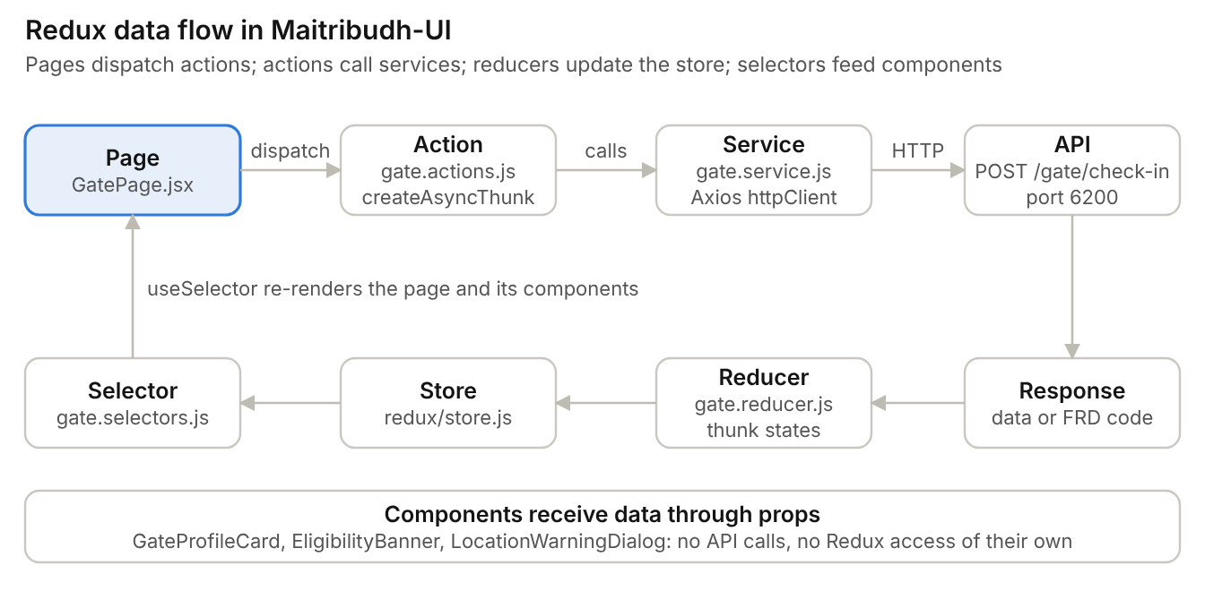
Figure 2. Redux data flow, using gate check-in as the example
Example: gate check-in, file by file
// services/gate.service.js
import httpClient from './httpClient';
import { API_ENDPOINTS } from '../constants/apiEndpoints';

/**
* Checks a person in at a gate.
* @param {{personId: number, gateId: number, locationId: number, confirmLocation: boolean}} payload
* @returns {Promise<object>} Visit returned by the API.
*/
export const checkIn = (payload) => httpClient.post(API_ENDPOINTS.GATE.CHECK_IN, payload);

// redux/actions/gate.actions.js
import { createAsyncThunk } from '@reduxjs/toolkit';
import { ACTION_TYPES } from '../../constants/actionTypes';
import * as gateService from '../../services/gate.service';
import { toErrorPayload } from '../../utils/errorHandler';

/** Checks a person in; on failure rejects with { code, message } (FRD message codes). */
export const checkInPerson = createAsyncThunk(
ACTION_TYPES.GATE.CHECK_IN,
async (payload, { rejectWithValue }) => {
try {
return await gateService.checkIn(payload);
} catch (error) {
return rejectWithValue(toErrorPayload(error));
}
},
);

// redux/reducers/gate.reducer.js
import { createSlice } from '@reduxjs/toolkit';
import { checkInPerson } from '../actions/gate.actions';
import { REQUEST_STATUS } from '../../constants/status';

const initialState = { gateId: null, locationId: null, profile: null, status: REQUEST_STATUS.IDLE, error: null };

const gateSlice = createSlice({
name: 'gate',
initialState,
reducers: {
/** Gate and location chosen at shift start. */
setGateAndLocation: (state, { payload }) => {
state.gateId = payload.gateId;
state.locationId = payload.locationId;
},
clearProfile: (state) => {
state.profile = null;
state.error = null;
},
},
extraReducers: (builder) => {
builder
.addCase(checkInPerson.pending, (state) => {
state.status = REQUEST_STATUS.LOADING;
state.error = null;
})
.addCase(checkInPerson.fulfilled, (state) => {
state.status = REQUEST_STATUS.SUCCEEDED;
})
.addCase(checkInPerson.rejected, (state, { payload }) => {
state.status = REQUEST_STATUS.FAILED;
state.error = payload;
});
},
});

export const { setGateAndLocation, clearProfile } = gateSlice.actions;
export default gateSlice.reducer;

// redux/selectors/gate.selectors.js
import { REQUEST_STATUS } from '../../constants/status';

/** @param {object} state Redux root state */
export const selectGateProfile = (state) => state.gate.profile;
export const selectGateError = (state) => state.gate.error;
export const selectGateAndLocation = (state) => ({ gateId: state.gate.gateId, locationId: state.gate.locationId });
export const selectIsGateBusy = (state) => state.gate.status === REQUEST_STATUS.LOADING;

// pages/gate/GatePage.jsx
import { useDispatch, useSelector } from 'react-redux';
import { checkInPerson } from '../../redux/actions/gate.actions';
import { selectGateAndLocation, selectGateError, selectGateProfile } from '../../redux/selectors/gate.selectors';
import { GateSelector, ScanPanel, GateProfileCard, EligibilityBanner, LocationWarningDialog } from '../../components/gate';
import { withAuth, withLayout, withRole } from '../../hoc';
import { GateLayout } from '../../layouts';
import { GATE_ROLES } from '../../constants/roles';
import { compose } from '../../utils/compose';

/**
* Gate screen: choose gate and location, scan or search, then check in.
* @returns {JSX.Element} The page.
*/
const GatePage = () => {
const dispatch = useDispatch();
const profile = useSelector(selectGateProfile);
const error = useSelector(selectGateError);
const { gateId, locationId } = useSelector(selectGateAndLocation);

const handleCheckIn = (confirmLocation = false) =>
dispatch(checkInPerson({ personId: profile.personId, gateId, locationId, confirmLocation }));

return (
<>
<GateSelector />
<ScanPanel />
{profile && <GateProfileCard profile={profile} onCheckIn={handleCheckIn} />}
<EligibilityBanner error={error} />
<LocationWarningDialog error={error} onConfirm={() => handleCheckIn(true)} />
</>
);
};

export default compose(withAuth, withLayout(GateLayout), withRole(GATE_ROLES))(GatePage);

// redux/store.js
import { configureStore } from '@reduxjs/toolkit';
import rootReducer from './rootReducer';
import { appConfig } from '../config/app.config';

/** The single Redux store; DevTools only outside production. */
const store = configureStore({ reducer: rootReducer, devTools: !appConfig.isProduction });

export default store;

// utils/compose.js
/**
* Applies HOCs right to left: compose(a, b, c)(Page) === a(b(c(Page))).
* @param {...Function} hocs Higher-order components.
* @returns {Function} Function that wraps a component.
*/
export const compose = (...hocs) => (Component) => hocs.reduceRight((wrapped, hoc) => hoc(wrapped), Component);

5. Application Design
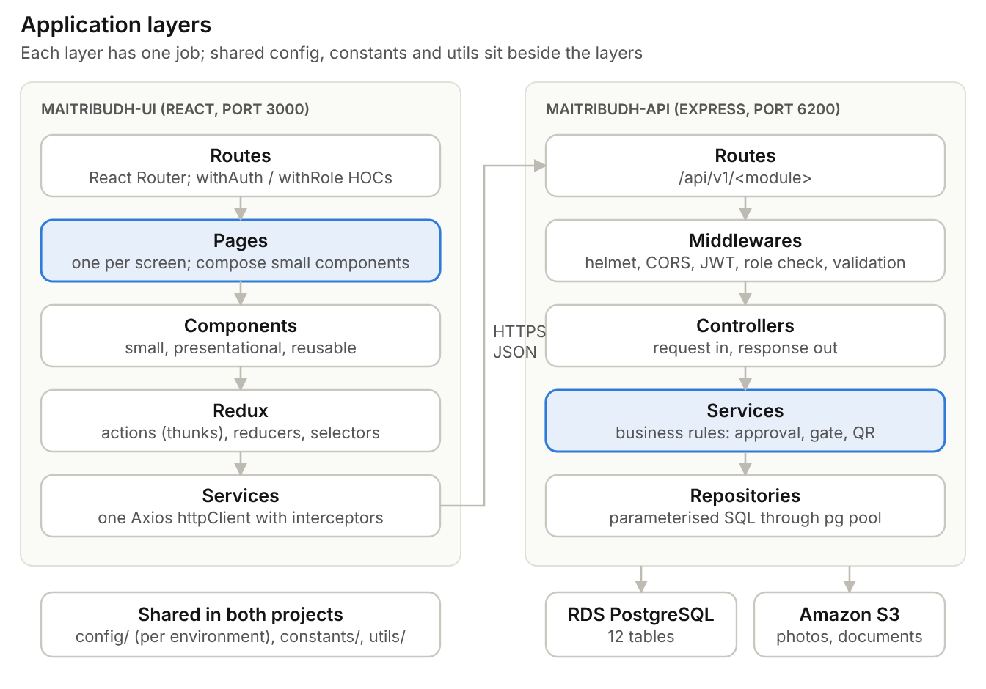
Figure 3. Application layers in Maitribudh-UI and Maitribudh-API

5.1 API layers
Layer | Responsibility | Must not
Routes | Map URL and method to middlewares and a controller | Contain logic
Middlewares | Security headers, CORS, JWT check, role check, request validation, upload limits, error handling | Call the database (except authentication)
Controllers | Read the request, call one service, send the standard response | Contain business rules or SQL
Services | Business rules: approval and self-approval, gate check order, QR versioning, lockout, audit, notifications | Read req / res or build SQL
Repositories | Parameterised SQL through the shared pg pool; transactions | Contain business rules
Utils / constants / config | Shared helpers, fixed values, environment values | Hold state

5.2 API endpoints (base path /api/v1)
Module | Endpoints | Roles
Auth | POST /auth/precheck, POST /auth/login, POST /auth/password, PUT /auth/password, POST /auth/logout, POST /auth/refresh | All
Users | GET/POST /users, PATCH /users/:id, POST /users/:id/reset-password | Super Admin, Admin
Masters | GET/POST/PUT/DELETE /categories, /locations, /lookups?type= | Admin (read: all)
Persons | GET /persons, POST /persons, GET/PUT /persons/:id, PATCH /persons/:id/status, PUT /persons/:id/locations | Admin, Approver, Reg. Officer
Approvals | GET /approvals, POST /approvals/:id/approve, /reject, /resubmit | Admin, Approver
QR | GET /public/qr?mobile= (no login), GET /persons/:id/qr | Public; front desk
Gate | POST /gate/scan, GET /gate/search, POST /gate/check-in, POST /gate/check-out, POST /gate/walk-in | Guard and above
Dashboard | GET /dashboard/summary, GET /dashboard/inside, PATCH /visits/:id/close | Dashboard roles; close: Admin
Blacklist | GET/POST /blacklist, PATCH /blacklist/:id/lift | Admin
Bulk upload | POST /bulk-uploads (multipart), GET /bulk-uploads/:id, GET /bulk-uploads/template | Users with bulk upload permission
Reports | GET /reports/:name, GET /reports/visit-history/export?format=xlsx|csv | Report roles
Notifications / audit | GET /notifications, PATCH /notifications/read, GET /audit | Own notifications; audit: Admin
Health | GET /health (load balancer check) | None

Standard response
// success
{ "success": true, "data": { ... }, "message": "Checked in" }
// error: code uses the FRD message codes
{ "success": false, "code": "MSG-GATE-03", "message": "BLACKLISTED PERSON — ENTRY NOT ALLOWED. Security has been alerted." }

5.3 UI design
Element | Rule
Pages | One page per screen; composes small components; dispatches actions and reads selectors; no direct API calls
Components | Small and single-purpose (guide: under 150 lines); presentational components receive data through props
Higher-order components | Cross-cutting behaviour wraps pages: authentication, role access, layout, error boundary, page title
State | Redux Toolkit: async actions in redux/actions, slices in redux/reducers, selectors in redux/selectors
Forms | React Hook Form + Zod schemas; field rules and messages from constants
Styling | MUI theme tokens; no hard-coded colours or sizes in components

Higher-order components
HOC | Purpose
withAuth | Redirects to login when there is no valid session
withRole(roles) | Allows the page only for the listed roles; others see the "Not permitted" page
withLayout(layout) | Wraps the page in MainLayout (portal), GateLayout (guard tablet) or PublicLayout (QR lookup)
withErrorBoundary | Shows a friendly error panel instead of a blank screen
withPageTitle(title) | Sets the browser title and page heading

Example: role guard HOC
import { useSelector } from 'react-redux';
import { Navigate } from 'react-router-dom';
import { ROUTES } from '../constants/routes';
import { selectUserRole } from '../features/auth/authSlice';
import { getDisplayName } from '../utils/component';

/**
* Allows the wrapped page only for the given roles.
* @param {React.ComponentType} WrappedComponent - Page to protect.
* @param {string[]} allowedRoles - Values from the ROLES constant.
* @returns {React.ComponentType} The guarded page.
*/
const withRole = (WrappedComponent, allowedRoles) => {
const RoleGuard = (props) => {
const role = useSelector(selectUserRole);
if (!allowedRoles.includes(role)) {
return <Navigate to={ROUTES.NOT_PERMITTED} replace />;
}
return <WrappedComponent {...props} />;
};
RoleGuard.displayName = `withRole(${getDisplayName(WrappedComponent)})`;
return RoleGuard;
};

export default withRole;

// Usage: compose HOCs with a util instead of nesting by hand
// export default compose(withAuth, withLayout(MainLayout), withRole([ROLES.ADMIN, ROLES.APPROVER]))(ApprovalQueuePage);

5.4 Screens and routes
Route | Screen | Roles
/login | Login, create password, forgot password | All users
/qr | Public QR lookup and download | Public (no login)
/dashboard | Dashboard widgets, inside list | Super Admin, Admin, Approver, Reg. Officer, Viewer
/gate | Scan or search, check-in / check-out, walk-in | Security Guard (landing page), Admin, Approver, Reg. Officer
/persons, /persons/new, /persons/:id | Search, register, view and edit | Admin, Approver, Reg. Officer
/approvals | Pending, Approved, Rejected tabs | Admin, Approver
/bulk-upload | Upload file and view results | Users with bulk upload permission
/blacklist | Add and lift entries | Admin
/reports | Six reports, Visit History export | Report roles
/masters, /users | Categories, locations, lookups; portal users | Admin (Admin users: Super Admin)
/audit | Audit log | Admin

6. Coding Standards
These standards apply to both applications. Tooling enforces them in the editor, in a pre-commit hook and in the pipeline.
Standard | How it is applied | Enforced by
ES6+ (ECMAScript modules) | import / export, const / let (never var), arrow functions, destructuring, template literals, spread, optional chaining, async / await | ESLint no-var, prefer-const, prefer-template
Higher-order components | Authentication, role access, layout, error boundary and title are HOCs, composed with utils/compose.js | Code review
Small, modular components | One component per file; one purpose; split when a component grows past about 150 lines | ESLint max-lines, review
Common logic in utils | Date, masking, formatting, file, QR token, pagination and response helpers live in utils/; no duplicated helpers | Review; import/no-duplicates
No hard-coded values | Roles, statuses, routes, messages (FRD codes), limits, time-outs and API paths live in constants/; environment values in config/ | ESLint no-magic-numbers (warning), review
ESLint rules | ESLint 9 flat config: recommended rules plus React, React Hooks, JSX accessibility, import and Prettier | npm run lint with zero warnings in CI
Formatting | Prettier: single quotes, semicolons, 2 spaces, 100 characters per line, trailing commas | Prettier check in CI; format on save
Documented code | JSDoc on every exported function, component, HOC and service; README per application; OpenAPI for the API | ESLint jsdoc plugin, review
Clean code | No unused variables, imports, files or commented-out code; no console.log (use the logger) | ESLint no-unused-vars, no-console
Imports (API) | Relative imports include the .js extension (Node.js ES modules); imports ordered: packages, then project files | ESLint import/extensions, import/order
Naming | camelCase variables and functions, PascalCase components, UPPER_SNAKE_CASE constants, kebab-case folders, *.service.js, *.repository.js | Review
Error handling | Async route handlers wrapped by asyncHandler; errors thrown as ApiError with an FRD code; one error middleware | Review, tests
Tests | Unit tests for services, utils and components; API tests for every endpoint; target 70% line coverage | CI fails below target
Commits | Husky + lint-staged run lint and format on staged files; Conventional Commit messages | Git hooks

6.1 ESLint configuration (UI)
// eslint.config.js
import js from '@eslint/js';
import globals from 'globals';
import react from 'eslint-plugin-react';
import reactHooks from 'eslint-plugin-react-hooks';
import jsxA11y from 'eslint-plugin-jsx-a11y';
import importPlugin from 'eslint-plugin-import';
import jsdoc from 'eslint-plugin-jsdoc';
import prettier from 'eslint-config-prettier';

export default [
{ ignores: ['dist', 'coverage'] },
js.configs.recommended,
react.configs.flat.recommended,
react.configs.flat['jsx-runtime'],
jsxA11y.flatConfigs.recommended,
importPlugin.flatConfigs.recommended,
jsdoc.configs['flat/recommended'],
{
files: ['**/*.{js,jsx}'],
languageOptions: { ecmaVersion: 'latest', sourceType: 'module', globals: globals.browser },
plugins: { 'react-hooks': reactHooks },
settings: { react: { version: 'detect' }, 'import/resolver': { node: { extensions: ['.js', '.jsx'] } } },
rules: {
...reactHooks.configs.recommended.rules,
'no-var': 'error',
'prefer-const': 'error',
'prefer-template': 'error',
'no-console': 'error',
'no-unused-vars': 'error',
eqeqeq: 'error',
'no-magic-numbers': ['warn', { ignore: [0, 1, -1], ignoreArrayIndexes: true }],
'max-lines': ['warn', { max: 150, skipBlankLines: true, skipComments: true }],
'import/no-duplicates': 'error',
},
},
prettier,
];

The API uses the same file with globals.node and without the React and JSX plugins.

6.2 Prettier
{
"singleQuote": true,
"semi": true,
"tabWidth": 2,
"printWidth": 100,
"trailingComma": "all",
"arrowParens": "always"
}

6.3 Constants and utils
// Maitribudh-API/src/constants/roles.js
/** Portal roles (FRD 3). */
export const ROLES = Object.freeze({
SUPER_ADMIN: 'SUPER_ADMIN',
ADMIN: 'ADMIN',
APPROVER: 'APPROVER',
REG_OFFICER: 'REG_OFFICER',
SECURITY_GUARD: 'SECURITY_GUARD',
VIEWER: 'VIEWER',
});

// Maitribudh-API/src/constants/app.constants.js
export const LOGIN_MAX_FAILURES = 5;
export const LOGIN_LOCK_MINUTES = 15;
export const DRAFT_EXPIRY_DAYS = 7;
export const MAX_UPLOAD_BYTES = 5 * 1024 * 1024;

// Maitribudh-API/src/utils/mask.js
/**
* Masks a mobile number to its last four digits.
* @param {string} mobile - 10-digit mobile number.
* @returns {string} Masked value, for example ******3210.
*/
export const maskMobile = (mobile = '') => mobile.replace(/\d(?=\d{4})/g, '*');

6.4 Package scripts
Application | Script | Does
API | npm run dev | Starts with NODE_ENV=development and auto-reload on port 6200
API | npm start | Starts the production build (used in the Docker image)
API / UI | npm run lint, npm run lint:fix | ESLint check / fix
API / UI | npm run format | Prettier write
API / UI | npm test, npm run test:coverage | Unit and integration tests
API | npm run db:migrate | Runs the SQL files in db/migrations in order
UI | npm run dev | Vite dev server on port 3000
UI | npm run build:dev, build:uat, build:prod | vite build --mode <environment>

7. Environment Configuration
Each environment has its own configuration. Values never live in code. Locally they come from .env.<environment> files, which are not committed; .env.example lists every variable. In AWS the API reads plain values from the ECS task definition and secrets from Secrets Manager, and the UI build uses the environment file of its stage.
Environment | Branch | UI address | API address | Database
Local | feature/* | http://localhost:3000 | http://localhost:6200 | Local PostgreSQL 16 or Dev RDS
Development | develop | dev.<domain> | dev.<domain>/api | RDS (single-AZ)
UAT | uat | uat.<domain> | uat.<domain>/api | RDS (single-AZ)
Production | main | <domain> (e.g. portal.maitribodh.org) | <domain>/api | RDS Multi-AZ

7.1 API variables
Variable | Example | Secret
NODE_ENV | development | uat | production
PORT | 6200
API_PREFIX | /api/v1
DB_HOST / DB_PORT / DB_NAME | mams-db.xxxx.rds.amazonaws.com / 5432 / mams
DB_USER / DB_PASSWORD | mams_api / (from Secrets Manager) | Yes
DB_SSL | true
DB_POOL_MAX | 20
JWT_SECRET | (from Secrets Manager) | Yes
JWT_GUARD_EXPIRES / JWT_IDLE_MINUTES | 12h / 30
QR_HMAC_SECRET | (from Secrets Manager) | Yes
AWS_REGION / S3_FILES_BUCKET | ap-south-1 / maitribodh-ams-files-prod
CORS_ORIGIN | https://portal.maitribodh.org
LOG_LEVEL | info
JOBS_ENABLED | true on one task, false on others

7.2 UI variables
Vite exposes only variables that start with VITE_. They end up in the browser, so they never hold secrets.
Variable | Example
VITE_APP_ENV | development | uat | production
VITE_API_BASE_URL | http://localhost:6200/api/v1 (local), /api/v1 (AWS)
VITE_APP_NAME | Maitribodh AMS

7.3 Loading configuration
// Maitribudh-API/src/config/index.js
import dotenv from 'dotenv';

const env = process.env.NODE_ENV ?? 'development';
// Local runs read .env.<environment>; in AWS the variables are already set by ECS.
dotenv.config({ path: `.env.${env}` });

/** Application configuration built once from environment variables. */
const config = Object.freeze({
env,
port: Number(process.env.PORT ?? 6200),
apiPrefix: process.env.API_PREFIX ?? '/api/v1',
db: {
host: process.env.DB_HOST,
port: Number(process.env.DB_PORT ?? 5432),
database: process.env.DB_NAME,
user: process.env.DB_USER,
password: process.env.DB_PASSWORD,
ssl: process.env.DB_SSL === 'true',
max: Number(process.env.DB_POOL_MAX ?? 20),
},
corsOrigin: process.env.CORS_ORIGIN,
jobsEnabled: process.env.JOBS_ENABLED === 'true',
});

export default config;

// Maitribudh-UI/vite.config.js
import { defineConfig } from 'vite';
import react from '@vitejs/plugin-react';

export default defineConfig({
plugins: [react()],
server: { port: 3000, strictPort: true },
});

8. Build, Packaging and Key Libraries
This section explains how each application is built and packaged, and how file upload (Multer), Material UI and loaders are set up.
Application | Build tool | Output | Runs on
Maitribudh-UI | Vite (Rollup for production bundles, esbuild for the dev server) | Static files in dist/: index.html, hashed JS and CSS, PWA service worker | S3 + CloudFront (dev server on port 3000 locally)
Maitribudh-API | No compile step: Node.js runs ES modules directly. The build is a Docker image | Docker image with src/, db/ and production dependencies | ECS Fargate (port 6200)

8.1 UI build (Vite)
Vite is the current standard build tool for React. Create React App, which used webpack, is no longer maintained. If the team prefers webpack, the equivalent configuration is in Appendix A.
Step | Command | What happens
1. Install | npm ci | Installs exact versions from package-lock.json
2. Check | npm run lint and npm test | ESLint with zero warnings; Vitest unit and component tests
3. Build | npm run build:uat (= vite build --mode uat) | Reads .env.uat; replaces import.meta.env.VITE_* values; bundles and tree-shakes the code with Rollup; minifies; splits code per page (lazy routes) and per vendor (React, MUI, Redux); adds a content hash to every file name; generates the PWA manifest and service worker
4. Output | dist/ | index.html, assets/*.js, assets/*.css, icons, manifest.webmanifest, sw.js
5. Deploy | aws s3 sync + CloudFront invalidation | Hashed assets cached for one year; index.html never cached, so users get the new version on the next load

vite.config.js
import { defineConfig, loadEnv } from 'vite';
import react from '@vitejs/plugin-react';
import { VitePWA } from 'vite-plugin-pwa';

/**
* Vite configuration. `mode` is development, uat or production and selects the .env file.
*/
export default defineConfig(({ mode }) => {
const env = loadEnv(mode, process.cwd(), 'VITE_');

return {
plugins: [
react(),
VitePWA({
registerType: 'autoUpdate',
manifest: {
name: env.VITE_APP_NAME,
short_name: 'MAMS',
display: 'standalone',
start_url: '/',
icons: [
{ src: '/icons/icon-192.png', sizes: '192x192', type: 'image/png' },
{ src: '/icons/icon-512.png', sizes: '512x512', type: 'image/png' },
],
},
}),
],
server: { port: 3000, strictPort: true },
preview: { port: 3000 },
build: {
outDir: 'dist',
sourcemap: mode !== 'production',
rollupOptions: {
output: {
manualChunks: {
react: ['react', 'react-dom', 'react-router-dom'],
mui: ['@mui/material', '@emotion/react', '@emotion/styled'],
redux: ['@reduxjs/toolkit', 'react-redux'],
},
},
},
},
};
});

Page-level code splitting
// routes/routeConfig.js: each page becomes its own small file in dist/assets
import { lazy } from 'react';
import { ROUTES } from '../constants/routes';

const GatePage = lazy(() => import('../pages/gate/GatePage'));
const DashboardPage = lazy(() => import('../pages/dashboard/DashboardPage'));

/** Route table used by AppRoutes. */
export const routeConfig = [
{ path: ROUTES.GATE, page: GatePage },
{ path: ROUTES.DASHBOARD, page: DashboardPage },
];

Deploy step in the pipeline
aws s3 sync dist/ s3://$UI_BUCKET --delete --exclude index.html \
--cache-control "public,max-age=31536000,immutable"
aws s3 cp dist/index.html s3://$UI_BUCKET/index.html --cache-control "no-cache"
aws cloudfront create-invalidation --distribution-id $CF_DISTRIBUTION_ID --paths /index.html

8.2 API build (Node.js and Docker)
The API is plain JavaScript using ES modules, which Node.js runs directly, so there is no Babel or webpack step. Relative imports include the .js extension, as Node.js requires. Locally npm run dev uses Node's built-in watch mode; in AWS the pipeline builds a Docker image.
Step | Command | What happens
1. Install | npm ci | Installs exact versions, including test and lint tools
2. Check | npm run lint, npm test, npm audit --audit-level=high | Lint, unit and API tests (Jest + Supertest), dependency scan
3. Image | docker build -t maitribudh-api:<git-sha> . | Multi-stage build: production dependencies only, non-root user, health check
4. Push | docker push <ecr-repo>:<git-sha> | Image stored in Amazon ECR
5. Migrate | npm run db:migrate | Applies new SQL files in db/migrations before the new version starts
6. Deploy | ECS service update | Rolling update: new tasks must pass /health before old tasks stop

Dockerfile
# ---- stage 1: production dependencies ----
FROM node:22-alpine AS deps
WORKDIR /app
COPY package*.json ./
RUN npm ci --omit=dev

# ---- stage 2: runtime image ----
FROM node:22-alpine
ENV NODE_ENV=production
WORKDIR /app
COPY --from=deps /app/node_modules ./node_modules
COPY package.json ./
COPY src ./src
COPY db ./db
USER node
EXPOSE 6200
HEALTHCHECK --interval=30s --timeout=5s CMD wget -qO- http://localhost:6200/health || exit 1
CMD ["node", "src/server.js"]

API package.json scripts
{
"type": "module",
"scripts": {
"dev": "cross-env NODE_ENV=development node --watch src/server.js",
"start": "node src/server.js",
"lint": "eslint . --max-warnings 0",
"lint:fix": "eslint . --fix",
"format": "prettier --write .",
"test": "cross-env NODE_ENV=test node --experimental-vm-modules node_modules/jest/bin/jest.js",
"db:migrate": "node db/migrate.js"
}
}

8.3 File upload with Multer
Photos, documents and bulk files go through Multer in the API. Files are kept in memory only long enough to check them and send them to S3; nothing is written to the container disk.
Step | Where | What happens
1 | UI: PhotoCapture | Camera capture or file pick; resized in the browser to 600 px; sent as multipart/form-data
2 | API: middlewares/upload.js | Multer memory storage; size limit and one file per field; MIME type allow-list
3 | API: services/file.service.js | Checks the real file type from its first bytes (file-type package); builds the S3 key photos/<uuid>.jpg; uploads with KMS encryption
4 | API: repository | Saves only the S3 key in person.photo_key or person.documents
5 | API: on display | Returns a pre-signed URL that expires in 5 minutes; the bucket stays private

Upload | Field | Allowed types | Limit
Photograph | photo | JPG, PNG | 5 MB
Document | document | PDF, JPG, PNG | 5 MB
Bulk file | file | XLSX, CSV | 10 MB

middlewares/upload.js
import multer from 'multer';
import { ALLOWED_MIME, FILE_LIMITS } from '../constants/app.constants.js';
import { MESSAGES } from '../constants/messages.js';
import ApiError from '../utils/ApiError.js';
import HTTP_STATUS from '../constants/httpStatus.js';

const storage = multer.memoryStorage();

/**
* Builds a Multer middleware that accepts one file in the given field.
* @param {string} field - Form field name.
* @param {string[]} mimeTypes - Allowed MIME types.
* @param {number} maxBytes - Maximum file size in bytes.
* @returns {import('express').RequestHandler} Upload middleware.
*/
const uploadSingle = (field, mimeTypes, maxBytes) =>
multer({
storage,
limits: { fileSize: maxBytes, files: 1 },
fileFilter: (req, file, done) =>
mimeTypes.includes(file.mimetype)
? done(null, true)
: done(new ApiError(HTTP_STATUS.BAD_REQUEST, 'MSG-REG-02', MESSAGES['MSG-REG-02'])),
}).single(field);

export const uploadPhoto = uploadSingle('photo', ALLOWED_MIME.PHOTO, FILE_LIMITS.PHOTO_BYTES);
export const uploadDocument = uploadSingle('document', ALLOWED_MIME.DOCUMENT, FILE_LIMITS.DOCUMENT_BYTES);
export const uploadBulkFile = uploadSingle('file', ALLOWED_MIME.BULK, FILE_LIMITS.BULK_BYTES);

services/file.service.js
import { randomUUID } from 'node:crypto';
import { GetObjectCommand, PutObjectCommand } from '@aws-sdk/client-s3';
import { getSignedUrl } from '@aws-sdk/s3-request-presigner';
import config from '../config/index.js';
import { s3Client } from '../config/s3.js';
import { SIGNED_URL_SECONDS } from '../constants/app.constants.js';
import { extensionOf } from '../utils/file.js';

/**
* Stores an uploaded file in the private S3 bucket.
* @param {Express.Multer.File} file - File from Multer memory storage.
* @param {string} prefix - S3 prefix: photos, documents or bulk-uploads.
* @returns {Promise<string>} S3 object key saved in the database.
*/
export const saveFile = async (file, prefix) => {
const key = `${prefix}/${randomUUID()}${extensionOf(file.originalname)}`;
await s3Client.send(
new PutObjectCommand({
Bucket: config.s3.filesBucket,
Key: key,
Body: file.buffer,
ContentType: file.mimetype,
ServerSideEncryption: 'aws:kms',
}),
);
return key;
};

/**
* Creates a short-lived download link for a private file.
* @param {string} key - S3 object key.
* @returns {Promise<string>} Pre-signed URL.
*/
export const getFileUrl = (key) =>
getSignedUrl(s3Client, new GetObjectCommand({ Bucket: config.s3.filesBucket, Key: key }), {
expiresIn: SIGNED_URL_SECONDS,
});

Route
// routes/person.routes.js
router.post(
'/:id/photo',
authenticate,
authorize(...REGISTRATION_ROLES),
uploadPhoto,
asyncHandler(personController.uploadPhoto),
);

8.4 Material UI setup
Item | Design
Packages | @mui/material, @emotion/react, @emotion/styled, @mui/icons-material, @mui/x-date-pickers (date fields)
Theme | theme/theme.js builds the theme from palette.js and typography.js; components use theme values, never literal colours or pixel sizes
Global styles | CssBaseline once at the root
Bundle size | Named imports from @mui/material are tree-shaken by Vite; MUI is split into its own cached vendor file
Wrappers | Common components (AppButton, FormTextField, DataTable, StatusChip) wrap MUI so the look is changed in one place
Responsive | MUI Grid and breakpoints; GateLayout is designed for a tablet or phone held in one hand

main.jsx
import { StrictMode } from 'react';
import { createRoot } from 'react-dom/client';
import { Provider } from 'react-redux';
import { BrowserRouter } from 'react-router-dom';
import { CssBaseline, ThemeProvider } from '@mui/material';
import store from './redux/store';
import theme from './theme/theme';
import App from './App';

createRoot(document.getElementById('root')).render(
<StrictMode>
<Provider store={store}>
<ThemeProvider theme={theme}>
<CssBaseline />
<BrowserRouter>
<App />
</BrowserRouter>
</ThemeProvider>
</Provider>
</StrictMode>,
);

8.5 Loaders
Loader | When | How
Global loader | While any request started by a user action is running (save, approve, check in) | MUI Backdrop + CircularProgress; shown when ui.pendingRequests > 0. The counter is updated for every async action through Redux matchers
Section loader | While one area loads its data (tables, dashboard widgets) | MUI Skeleton rows while that module's status is LOADING
Button loader | While the action of that button runs | AppButton with a loading prop: disabled with a spinner, so it cannot be clicked twice
Page loader | While a lazy page file downloads | Suspense fallback around the routes
Silent refresh | Dashboard 30-second refresh, notification polling | Actions called with { silent: true } are not counted, so the screen does not flash

redux/reducers/ui.reducer.js
import { createSlice, isAnyOf, isFulfilled, isPending, isRejected } from '@reduxjs/toolkit';

/** Background refreshes pass { silent: true } and are not counted. */
const isTracked = (action) => !action.meta?.arg?.silent;

const initialState = { pendingRequests: 0, snackbar: null };

const uiSlice = createSlice({
name: 'ui',
initialState,
reducers: {
showSnackbar: (state, { payload }) => {
state.snackbar = payload;
},
hideSnackbar: (state) => {
state.snackbar = null;
},
},
extraReducers: (builder) => {
builder
.addMatcher((action) => isPending()(action) && isTracked(action), (state) => {
state.pendingRequests += 1;
})
.addMatcher((action) => isAnyOf(isFulfilled(), isRejected())(action) && isTracked(action), (state) => {
state.pendingRequests = Math.max(0, state.pendingRequests - 1);
});
},
});

export const { showSnackbar, hideSnackbar } = uiSlice.actions;
export default uiSlice.reducer;

components/common/Loader/Loader.jsx and App.jsx
import PropTypes from 'prop-types';
import { Backdrop, CircularProgress } from '@mui/material';

/**
* Full-screen loader.
* @param {{open: boolean}} props - Whether the loader is visible.
* @returns {JSX.Element} Backdrop with a spinner.
*/
const Loader = ({ open }) => (
<Backdrop open={open} sx={{ zIndex: (theme) => theme.zIndex.modal + 1, color: 'common.white' }}>
<CircularProgress color="inherit" aria-label="Loading" />
</Backdrop>
);

Loader.propTypes = { open: PropTypes.bool.isRequired };

export default Loader;

// App.jsx: the page reads Redux; the common component only receives props
const App = () => {
const isBusy = useSelector(selectIsAppBusy);
return (
<>
<AppRoutes />
<Loader open={isBusy} />
<AppSnackbar />
</>
);
};

9. Security Architecture
Area | Design
Login | Username and password. Users are created without a password and create it at first login. Forgot Password uses old + new password on the login page. No OTP, email link, SMS or WhatsApp
Passwords | bcrypt (cost 12); minimum 10 characters with letters and digits
Lockout | 5 wrong passwords in 15 minutes lock the account for 15 minutes; login endpoint also rate-limited per IP
Sessions | JWT access token. Security Guard: 12-hour shift token, no idle logout. Other roles: 30-minute idle timeout through token refresh on activity. Logout and password reset increase token_version, which revokes existing tokens
Authorisation | authorize(roles) middleware on every route; the UI hides what a role cannot use but the API decides
QR | Token AMS1.<Person ID>.<version>.<HMAC-SHA256> signed with a secret from Secrets Manager; a replaced QR fails the version check
Public QR lookup | No OTP, CAPTCHA or rate limit by decision; returns only Active, non-blacklisted registrations; every lookup audited with a masked mobile. Security personnel validate the person at the gate
Data protection | TLS everywhere (ACM certificates); RDS and S3 encrypted with KMS; ID numbers encrypted by the API; mobile numbers masked for non-Admin users
Files | Private S3 bucket; uploads checked for type and size (5 MB); downloads through pre-signed URLs that expire in minutes
API hardening | helmet headers, strict CORS origin, request size limits, zod validation, parameterised SQL only
Network | API and database in private subnets; database accepts connections only from the API security group on port 5432; only 443 open to the internet
Edge | AWS WAF managed rule sets (common attacks, known bad inputs, IP reputation) on CloudFront
Audit | Every data change, login, failed login, QR generation, gate event, bulk upload and export written to audit_log
DPDP | DPDP compliance applies; detailed requirements are pending from the business side

10. Data Architecture

10.1 Database
Amazon RDS for PostgreSQL 16 holds 12 tables, described in Database Design v2.0. The API connects through a pg connection pool with TLS. Schema changes are numbered SQL migration files in Maitribudh-API/db/migrations.
Table | Holds
app_user | Portal users, roles, password hash, lockout, bulk upload permission
category, location, lookup_value | Master data: categories, gates and areas, and all small lists
person, person_location | Registrations (category fields as JSON) and assigned locations
approval_history, blacklist | Approval decisions and blacklist entries
visit | Check-in and check-out with gate and location
bulk_upload, notification, audit_log | Bulk upload results, in-app notifications, audit trail

10.2 File storage (Amazon S3)
Prefix | Content | Lifecycle
photos/ | Person photographs (resized to 600 px) | Kept with the record
documents/ | ID proof, appointment letter, membership form | Kept with the record
bulk-uploads/ | Uploaded bulk files | Delete after 90 days
exports/ | Visit History exports | Delete after 7 days

One private bucket per environment, e.g. maitribodh-ams-files-prod. QR images are not stored: the API generates the PNG when the person downloads it or the front desk prints it.

11. External Integrations
Phase 1 has no paid external integrations. Notifications are in-app only.
Service | Phase 1 | Later option
Email (password reset, notifications) | Not used. Password change is done on the login page | Amazon SES with the client's sender domain
SMS / OTP | Not used (recurring cost) | MSG91, TextLocal or Twilio with DLT registration
WhatsApp (QR, confirmations) | Not used. The QR is downloaded from the lookup page or printed | Meta WhatsApp Business API or a provider
External login (Google, Microsoft, SSO) | Not used; application login with JWT | Azure AD / SSO

12. Background Jobs
Job | Schedule | Action
Overstay alert | Every 5 minutes | Finds open visits past the category cut-off (IST), notifies Admins and the Security Head once per visit
Draft clean-up | Daily 02:00 IST | Deletes drafts older than 7 days
Notification clean-up | Daily 02:15 IST | Deletes notifications older than 30 days

Jobs run inside the API with node-cron. Only the task started with JOBS_ENABLED=true runs them, so alerts are not sent twice when several API tasks are running. An alternative is an EventBridge Scheduler rule that starts a one-off ECS task.

13. AWS Infrastructure

13.1 Network
Component | Design
VPC | One VPC per environment across two Availability Zones
Public subnets | Application Load Balancer, NAT gateway
Private app subnets | ECS Fargate tasks running Maitribudh-API
Private DB subnets | RDS PostgreSQL (no internet access)
DNS and certificates | Route 53 for the domain; ACM certificates for CloudFront and the load balancer
Security groups | Load balancer: 443 from CloudFront; API: 6200 from the load balancer; RDS: 5432 from the API only

13.2 Hosting options
 | Option A (recommended) | Option B (small budget)
Frontend | React build in S3, served by CloudFront | Served by Nginx on the same EC2 instance
Backend | ECS Fargate, 2 tasks across 2 AZs, auto scaling | Docker on one EC2 instance
Load balancing | Application Load Balancer with health check on /health | Nginx reverse proxy
Database | RDS PostgreSQL Multi-AZ | RDS PostgreSQL single-AZ
Suitable for | Production, 99.5% availability target | Initial MVP or pilot

13.3 Monitoring
Service | Used for
CloudWatch Logs | API logs (JSON from pino), ECS and RDS logs
CloudWatch metrics and alarms | API errors and latency, ECS CPU and memory, RDS CPU, storage and connections, unhealthy targets
RDS Performance Insights | Slow queries
AWS Backup / RDS automated backups | Daily backups with point-in-time recovery (7 to 35 days)

14. CI/CD and Environments
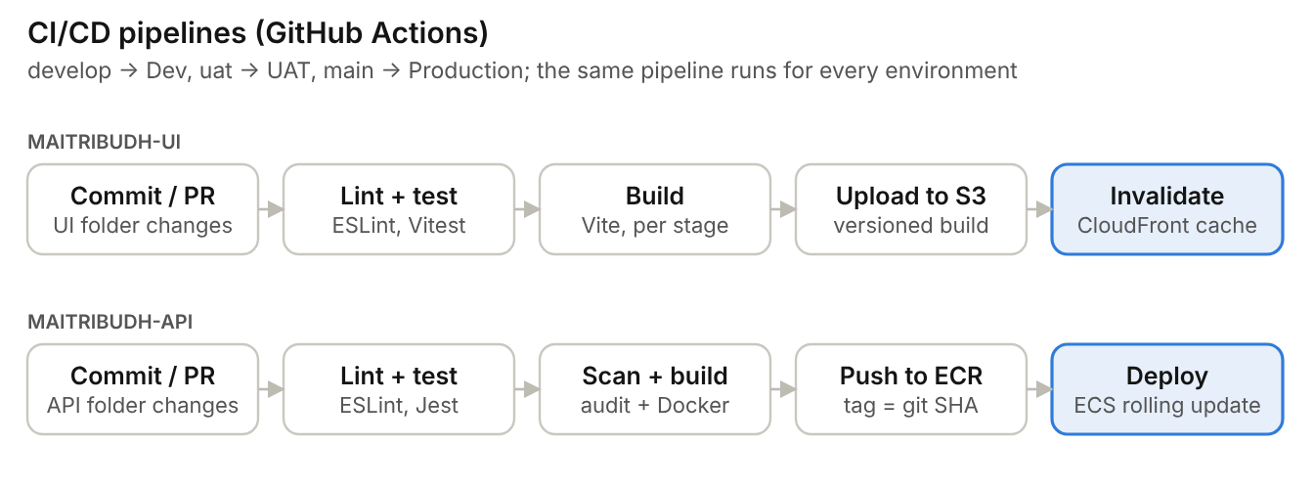
Figure 4. CI/CD pipelines for Maitribudh-UI and Maitribudh-API
Item | Design
Repository | GitHub repository Maitribudh-AMS; separate workflows for API and UI, triggered by changes in their own folder
Branches | feature/* → pull request to develop (Dev) → uat (UAT) → main (Production)
Pull request checks | ESLint (zero warnings), Prettier check, unit and API tests with coverage, npm audit (fail on high), build
UI deployment | vite build --mode <env>, upload to the environment's S3 bucket, CloudFront invalidation
API deployment | Docker image tagged with the git commit, pushed to ECR, ECS rolling update with health checks
Database changes | Migration step runs npm run db:migrate before the new API version starts
Infrastructure | Terraform per environment (separate state); applied through a reviewed pipeline
Production approval | GitHub environment protection: a named approver confirms each production deployment

15. Non-Functional Requirements
Requirement | Target | How the architecture meets it
Search | 3 seconds or less | Indexes on mobile, name, status and date; paginated results (25 rows)
QR scan to result | 2 seconds or less | One query for the gate check; small payload; API close to the database
Dashboard | 5 seconds or less | One query for all widgets; dashboard data refreshed every 30 seconds
Availability | 99.5% | Two API tasks across AZs, RDS Multi-AZ, CloudFront for the UI
Scalability | Indicative 100,000+ persons, 500 concurrent users | ECS auto scaling; RDS instance can be resized; Redis can be added later
Gate continuity | Paper register when offline | Manual register fallback (no offline mode in Phase 1)
Usability | Responsive, mobile friendly | MUI responsive layouts; PWA on gate tablets

16. AWS Services Required
Mandatory | Optional / later
VPC, subnets, NAT gateway | Amazon ElastiCache (Redis), if load requires it
Route 53, ACM | Amazon SES / SNS, if notifications are added later
IAM, security groups | Amazon GuardDuty
Secrets Manager, KMS | AWS Backup (beyond RDS automated backups)
S3 (UI and files), CloudFront, WAF
ECS Fargate, ECR, Application Load Balancer
RDS for PostgreSQL
CloudWatch

17. Client Inputs and Infrastructure Checklist
Area | Needed from the client
Cloud | AWS account (or sub-account per environment) with billing; preferred region
Domain | Domain name and DNS access, e.g. portal.maitribodh.org
Users | Super Admin details (IT team), Admin, Approver, Registration Officer and Security Guard users
Master data | Categories and the broad category mapping, subcategories, departments, job roles, gates and areas (open / restricted), permission levels, blacklist reasons, program batches
Policies | Backup and disaster recovery expectations; data retention and DPDP requirements
DevOps | GitHub organisation, Maitribudh-AMS repository, GitHub Actions access, approvers for production
Devices | Android tablets or phones for gates with a rear camera and reliable mobile data or Wi-Fi

Paid email, SMS and WhatsApp providers are not needed for Phase 1.

Appendix A. webpack Alternative for Maitribudh-UI
Use this only if the team decides to build the UI with webpack instead of Vite. Everything else in this document stays the same. Differences: environment values are read as process.env.VITE_* instead of import.meta.env.VITE_*, and Babel transpiles JSX.
Package | Purpose
webpack, webpack-cli, webpack-dev-server | Bundler, command line and dev server (port 3000)
babel-loader, @babel/core, @babel/preset-env, @babel/preset-react | Transpile modern JavaScript and JSX
html-webpack-plugin | Generates index.html with the hashed bundles
style-loader, css-loader | Plain CSS files (MUI styles come from Emotion at runtime)
dotenv-webpack | Loads .env.<environment> at build time
workbox-webpack-plugin | PWA service worker

webpack.config.js
import path from 'node:path';
import { fileURLToPath } from 'node:url';
import HtmlWebpackPlugin from 'html-webpack-plugin';
import Dotenv from 'dotenv-webpack';
import { GenerateSW } from 'workbox-webpack-plugin';

const dirname = path.dirname(fileURLToPath(import.meta.url));

/**
* webpack configuration.
* Build: webpack --mode production --env APP_ENV=uat
*/
export default (env, argv) => {
const isProduction = argv.mode === 'production';
const appEnv = env.APP_ENV ?? 'development';

return {
mode: isProduction ? 'production' : 'development',
entry: './src/main.jsx',
output: {
path: path.resolve(dirname, 'dist'),
filename: 'assets/[name].[contenthash].js',
publicPath: '/',
clean: true,
},
resolve: { extensions: ['.js', '.jsx'] },
module: {
rules: [
{ test: /\.jsx?$/, exclude: /node_modules/, use: 'babel-loader' },
{ test: /\.css$/, use: ['style-loader', 'css-loader'] },
{ test: /\.(png|jpe?g|svg|woff2?)$/, type: 'asset' },
],
},
plugins: [
new HtmlWebpackPlugin({ template: './index.html' }),
new Dotenv({ path: `./.env.${appEnv}` }),
...(isProduction ? [new GenerateSW({ clientsClaim: true, skipWaiting: true })] : []),
],
optimization: { splitChunks: { chunks: 'all' } },
devServer: { port: 3000, historyApiFallback: true, hot: true },
devtool: isProduction ? false : 'eval-source-map',
};
};

babel.config.json and scripts
{
"presets": [
["@babel/preset-env", { "targets": "defaults" }],
["@babel/preset-react", { "runtime": "automatic" }]
]
}

"scripts": {
"dev": "webpack serve --mode development",
"build:dev": "webpack --mode production --env APP_ENV=development",
"build:uat": "webpack --mode production --env APP_ENV=uat",
"build:prod": "webpack --mode production --env APP_ENV=production"
}

